# **Blue Team: Summary of Operations**

## **Table of Contents**

* Network Topology
* Description of Targets
* Monitoring the Targets
* Patterns of Traffic & Behavior
* Suggestions for Going Further

### **Network Topology**

The following machines were identified on the network:

* Kali
  + **Operating System**: Linux
  + **Purpose**: Attacker
  + **IP Address**:192.168.1.90
* ELK
  + **Operating System**: Linux
  + **Purpose**: Observation with kibana
  + **IP Address**:192.168.1.100
* Capstone
  + **OS**: Linux
  + **Purpose**: Alerting/ Sending logs
  + **IP Address**: 192.168.1.105
* Target1
  + **OS**: Linux
  + **Purpose**: Target
  + **IP Address**: 192.168.1.110

### **Description of Targets**

The target of this attack was: Target 1- IP address 192.168.1.110

Target 1 is an Apache web server and has SSH enabled, so ports 80 and 22 are possible ports of entry for attackers. As such, the following alerts have been implemented:

### **Monitoring the Targets**

Traffic to these services should be carefully monitored. To this end, we have implemented the alerts below:

#### **Excessive HTTP Errors**

Alert 1 is implemented as follows:

* **Metric**: when sum of http.request.bytes over all documents
  + Packets from same IP to all destination ports
* **Threshold**: above 3500 for the last 1 minute
* **Vulnerability Mitigated**: Network/Port scan
* **Reliability**: medium reliability due to the fact that one spike was under the threshold and created a false negative

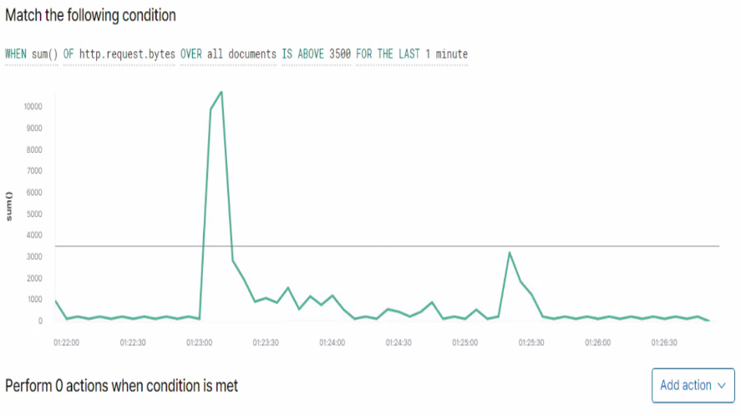

#### **HTTP Request Size Monitor**

Alert 2 is implemented as follows:

* **Metric**: when count grouped over top 5 ‘http.response.status.code’
  + packets attempting to access network resources
* **Threshold**: above 400 for the last 5 minutes
* **Vulnerability Mitigated**: Wordpress enumeration
* **Reliability**: low reliability since it only reached 52 “404” responses, not triggering it at that very high 400 alert

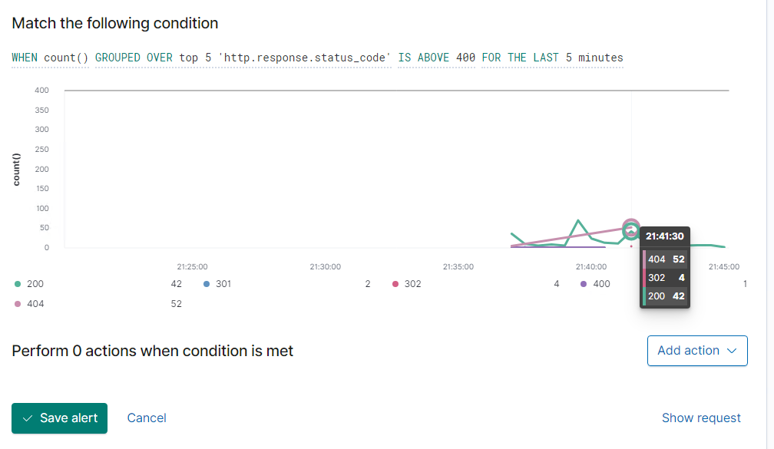

#### **CPU Usage Monitor**

Alert 3 is implemented as follows:

* **Metric**: when max of system.process.cpu.total.pct over all documents
  + system CPU processes
* **Threshold**: above .5 for the last 5 minutes
* **Vulnerability Mitigated**: Password cracking
* **Reliability**: low reliability since the passwords hashes were cracked outside the users machine and did not trigger an alert

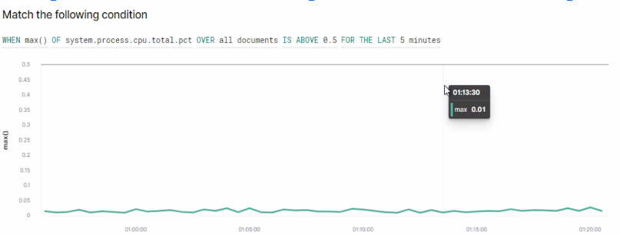

### **Suggestions for Going Further (Optional)**

The logs and alerts generated during the assessment suggest that this network is susceptible to several active threats, identified by the alerts above. In addition to watching for occurrences of such threats, the network should be hardened against them. The Blue Team suggests that IT implement the fixes below to protect the network:

* Vulnerability 1:network/port scan
  + **Patch**: Cyber Threat Intelligence (CTI), properly installed firewall with updated applications, closed ports, TCP wrappers,
  + **Why It Works**: CTI works by collecting data and processing it throughout history to prevent “like” attacks from happening. It studies who or what is attacking, why they are choosing the target and how to spot signs of compromise. A firewall is able to detect the sccan and shut it down. A TCP wrapper gives admins control over what IP address can have access to the network.

(*What Is Cyber Threat Intelligence?*, n.d.)

* Vulnerability 2: wordpress enumeration
  + **Patch**: add the following code to the functions.php file
    - // block WP enum scans
    - // https://m0n.co/enum
    - if (!is_admin()) {
    - // default URL format
    - if (preg_match('/author=([0-9]*)/i',$_SERVER['QUERY_STRING'])) die();
    - add_filter('redirect_canonical', 'shapeSpace_check_enum', 10, 2);}
    - function shapeSpace_check_enum($redirect, $request) {
    - // permalink URL format
    - if (preg_match('/\?author=([0-9]*)(\/*)/i', $request)) die();
    - else return $redirect;}
  + **Why It Works**: This patch will check if the request is for any page in the WP Admin Area and block the request if it is for a query-string author archive.
  + **Other Patches**:block request at the server level by adding code to the root.htaccess file, change all user display names to anything other than the login name, make sure author tags are not displaying login names

(Starr, 2018)

* Vulnerability 3: Brute Force/ password cracking
  + **Patch**: Strict password policies including MFA, long/complex passwords, different passwords for all accounts, and the use of passphrases
  + **Why It Works**: Making a complex password/ passphrase will avoid the cracking software detecting the correct combination used to log in. MFA will just add another layer of defense that the attacker would need to penetrate.

**References**

Starr, J. (2018, August 3). *Stop User Enumeration in WordPress*. Perishable Press. Retrieved August 22, 2022, from https://perishablepress.com/stop-user-enumeration-wordpress/

*What Is Cyber Threat Intelligence?* (n.d.). Fortinet. Retrieved August 22, 2022, from https://www.fortinet.com/resources/cyberglossary/cyber-threat-intelligence